FLASH November 2026

TECHNICAL

ASSESSMENT

01 Bug Prioritization
02 Test Analysis
03 API Testing Approach
04 Web Automation and Test Evidence

Prepared by: Jason Barron
Email: jasonbarronyou222@gmail.com

GitHub repository:
https://github.com/Jason-Barron07/qa-automation-assessment

TASK 1: Bug Prioritization and Justification

BUG | Priority | Priority Justification
Complete registration button fails | Urgent | Users cannot complete registration or create an account, preventing new customers from signing up and potentially causing the business to lose sales.
Password reset email not sent | High | Users cannot regain access to their accounts, preventing paying customers from using their subscriptions.
Language switcher fails | High | Users may struggle to understand the website if they cannot select their preferred language, making it difficult to register or use the service.
Birth-month dropdown only shows November | Normal | Blocks accurate registration. Should be escalated if it prevents registration or required age checks.
About-us footer links return home | Low | Users cannot reach the About Us page through the footer links, but they can still register and use the main service.

TASK 2: Voucher System Test Analysis
Area | Key testing considerations
Business rules | Confirm voucher values, expiry periods, and who can redeem them. Clarify whether partial redemption, cancellations, and refunds are allowed.
Voucher creation | Check that each voucher has a unique code, the correct value, and the correct expiry date. Confirm it is issued to the intended customer.
Redemption and tracking | Check that valid vouchers can be redeemed and their status updates correctly. Record each successful redemption and prevent single-use vouchers from being used again.
Data integrity | Confirm that balances and transaction records remain accurate. Repeated requests or two customers attempting to redeem the same voucher must not cause duplicate deductions or redemptions.
Security | Check that users can only view and use vouchers they are allowed to access. Voucher codes should be difficult to guess, and sensitive customer information should be protected.
Performance | Check response times during normal use and busy periods. Confirm that many customers can redeem vouchers at once without incorrect results or lost transactions.
Edge cases | Test expired, invalid, cancelled, and already used vouchers. Include missing information, incorrect code formats, and redemption just before and after expiry.
Connected systems | Check that the voucher system exchanges information correctly with payment, account, and other connected services. Test slow responses and unavailable services.
Failure and recovery | Check what happens if a request fails or the connection drops during redemption. Retrying should not process the same transaction twice, and customers should receive a clear outcome.

TASK 3: Cat Facts API Testing
3a: Testing Approach and Execution Plan
- What would you test about this API?
I would test all three endpoints in the collection, focusing on their responses and supported request options.
Endpoint:
GET /breeds
What I would test:
Check that the API returns a list of cat breeds. Test the supplied limit=1 setting and other supported limits.

Endpoint:
GET /fact
What I would test:
Check that the API returns a random cat fact. With max_length=140, check that a returned fact does not exceed 140 characters.

Endpoint:
GET /facts
What I would test:
Check that the API returns a list of cat facts. Verify that the number of results respects limit and that every returned fact respects max_length.

Across these endpoints I would also test:
Area | Testing consideration
Response format | Check status codes, JSON content type, required fields, and data types.
Invalid inputs | Test negative numbers, zero, and text in numeric parameters. Confirm the expected handling.
Boundary cases | Test small and large values, omitted parameters, and requests where no facts match the length limit.
Performance | Measure response times against an agreed target.
Security | Check HTTPS and ensure errors do not expose sensitive information.
Data integrity | Confirm fact lengths match the text, match the returned data.
Integration | Check how a consuming application handles timeouts, unavailable services, and unexpected responses.

- Why would you test these aspects?
- Successful requests confirm that the API provides its intended service. Format and data checks help ensure that applications can read and use the responses reliably.
- Testing limit and max_length confirms that the API follows the caller’s instructions. Invalid inputs and boundary cases help identify failures that normal requests may miss.

- How would you approach the testing?

- I would import the collection into Postman and run each request manually. I would inspect the responses and confirm the expected fields and status codes.
- I would then prepare positive, negative, and boundary test cases. Any unexpected behaviour would be reported as a bug.

Step | Process
1. Import the collection | Import the supplied collection into Postman. Confirm limit=1 for /breeds and /facts, and max_length=140 for /fact and /facts.
2. Explore the requests | Send all three requests with the supplied Accept: application/json header and review their responses.
3. Prepare the setup | Confirm the base URL is https://catfact.ninja and that the request parameters are enabled.
4. Add test assertions | Add Post-response scripts to check status codes, response fields, item counts, and fact length limits.
5. Execute the tests | Run all three requests using the Collection Runner.
6. Review the results | Review passed and failed assertions. Compare any failures with the actual responses.
7. Document and export | Record actual results, defects, assumptions, and limitations. Export the collection with its test scripts and include instructions for running it.
3b: Practical Tests and Results

Endpoint | Expected result | Actual result
/breeds?limit=1 | HTTP 200 with a JSON response containing one breed and the fields breed, country, origin, coat, and pattern. | HTTP 200 received. One breed returned with all expected fields. See Figure 1.
/fact?max_length=140 | HTTP 200 with a JSON response containing a non-empty fact, a numeric length, and fact text no longer than 140 characters. | HTTP 200 received. A non-empty fact was returned within the 140-character limit, with a numeric length. See Figure 2.
/facts?limit=1&max_length=140 | HTTP 200 with a JSON response containing exactly one fact, no longer than 140 characters, and pagination values current_page=1 and per_page=1. | HTTP 200 received. One fact was returned within the 140-character limit. All five assertions passed. See figure 3.

API Test Evidence:
GET /breeds: return list of breed actual results:
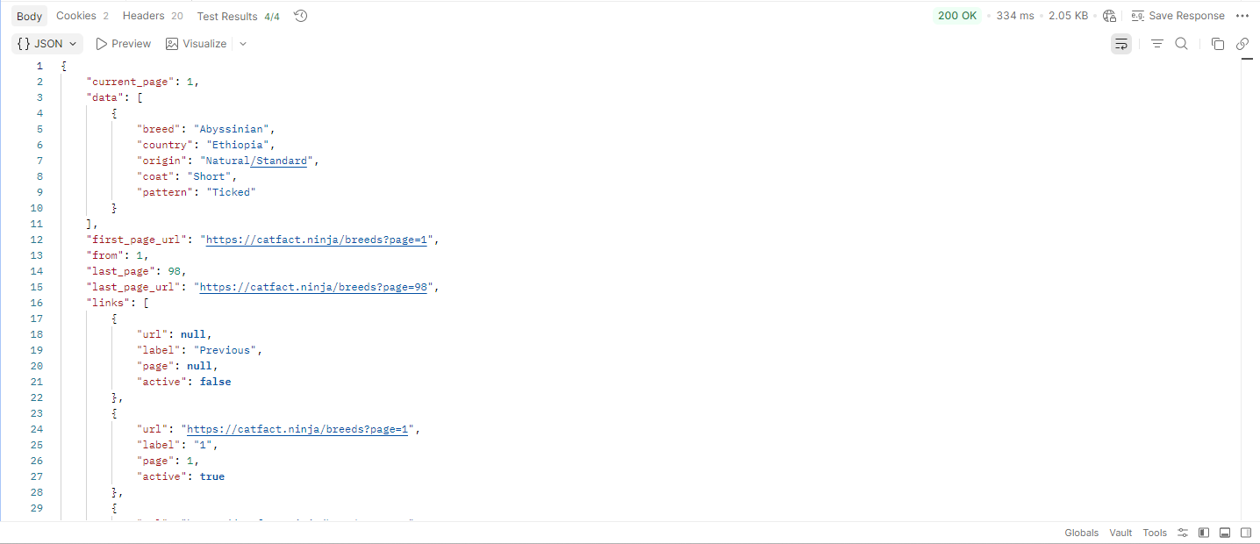
Figure 1: Breed request results

GET /fact: returns a random cat fact:
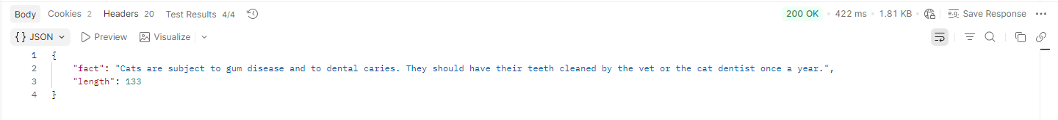
Figure 2: Random cat fact

GET /facts: returns list of cat facts:
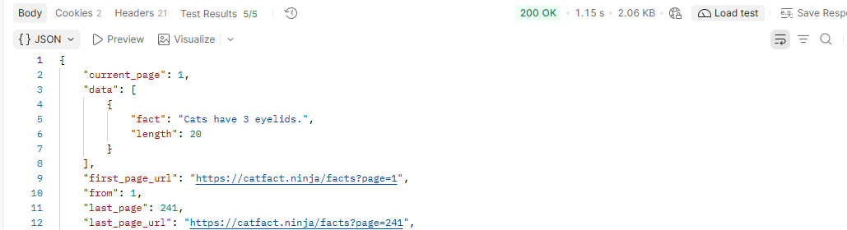
Figure 3: List of cat facts
Cat API collection run:
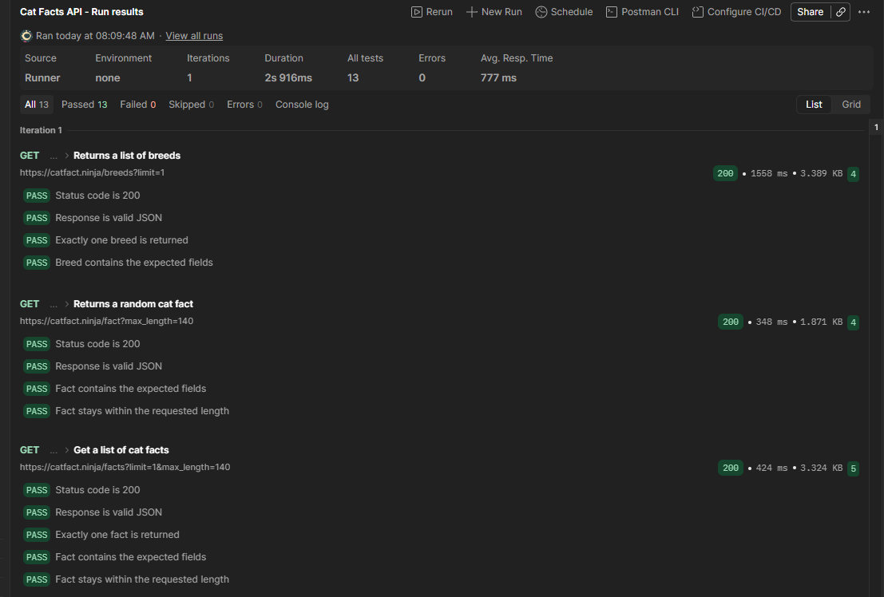
Task 4: Swag Labs Web Automation and Test Evidence
Automate the required Swag Labs shopping journey using Playwright BDD and TypeScript.

Item | Implementation
Automation framework | Playwright
Language | TypeScript
Test style | BDD using Given, When, and Then
Design pattern | Page Object Model
Browser | Chromium
Test data | Separate JSON file
Reporting | Playwright HTML report and JUnit results
GitHub: https://github.com/Jason-Barron07/qa-automation-assessment
(See README.md file for setup instructions)

4.1 Test coverage
Area | What is verified | Scenarios
Login | Valid login and five negative cases | 6
Sorting | All four sorting options and the complete product order | 4
Cart | Adding all products, badge count, and calculated total | 2
Checkout | Valid information, three missing-field cases, item total, and tax | 6
Purchase completion | Success messages, cleared badge, All Items, empty cart, and logout | 4
Total |  | 22  See Figure 4
4.2 Test Execution Evidence
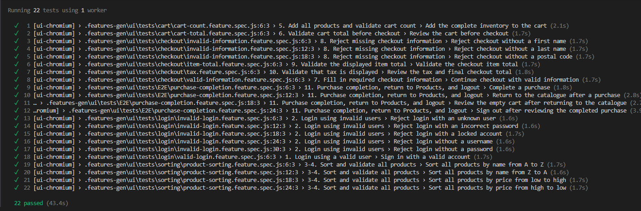
My latest verified run passed 22 tests with no failures or skips.
Figure 4: Playwright execution summary showing 22 passed scenarios.

